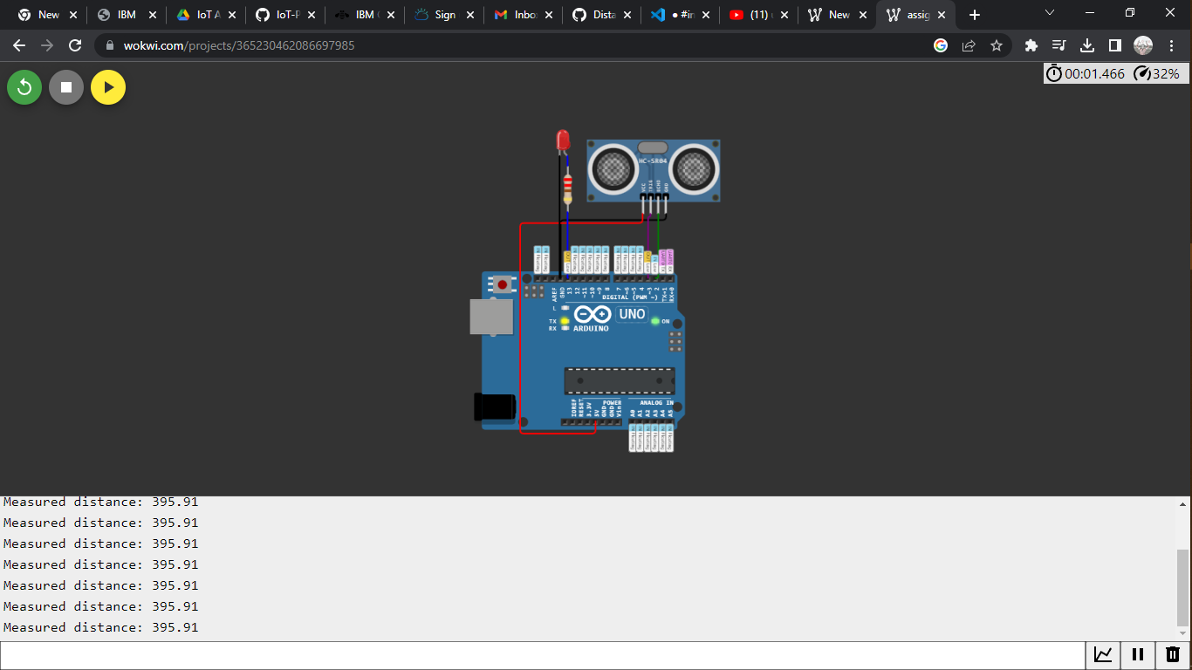

**Project link**

[**https://wokwi.com/projects/365230462086697985**](https://wokwi.com/projects/365230462086697985)

**CODE**

 HC-SR04 Ultrasonic Sensor

#define ECHO_PIN 2

#define TRIG_PIN 3

void setup() {

**Serial**.begin(115200);

  pinMode(LED_BUILTIN, OUTPUT);

  pinMode(TRIG_PIN, OUTPUT);

  pinMode(ECHO_PIN, INPUT);

}

float readDistanceCM() {

  digitalWrite(TRIG_PIN, LOW);

  delayMicroseconds(2);

  digitalWrite(TRIG_PIN, HIGH);

  delayMicroseconds(10);

  digitalWrite(TRIG_PIN, LOW);

  int duration = pulseIn(ECHO_PIN, HIGH);

  return duration * 0.034 / 2;

}

void loop() {

  float distance = readDistanceCM();

  bool isNearby = distance < 100;

  digitalWrite(LED_BUILTIN, isNearby);

**Serial**.print("Measured distance: ");

**Serial**.println(readDistanceCM());

  delay(100);

}